# **PEEE I Practical Session 3 (Sample Answer)**

Ohm’s Law

________________________________________________________________________

**1. OBJECTIVES**

* To learn the proper use and connection of the variable dc power supply.
* To measure the dc voltage and dc current in a resistor using digital multimeters (DMMs).
* To verify that the ratio of voltage to current in a resistor follows Ohm’s law.

**2. EQUIPMENT**

* DC power supply.
* Digital Multimeters (DMMs).
* Training kit with a 2.2 kΩ resistor.

**3. PROCEDURE**

3.1 Keep the DC power supply remaining OFF.

3.2 Turn all knobs on the DC power supply fully counterclockwise to begin with minimum values.

3.3 Set the **Operation Mode** to **Independent** by releasing/extending the 2 push buttons in the middle of the power supply panel. This ensures that we have **2** independent output channels: CH1 and CH2.

3.4 Set the **CURRENT knob** approximately to the **9 o’clock position**. This limits the output current not to be too high.

3.5 Switch the DMM (**Ammeter**) to the **DC CURRENT mode**. See Figure 3.1. Ensure that the **red colour probe** is plugged into the **mA/μA socket**, and the **BLACK colour probe** is plugged into the **COM socket.**

3.6 Switch the DMM (**Voltmeter**) to the **DC VOLTAGE mode**. See Figure 3.2. Ensure that the **red colour probe** is plugged into the **‘V’ socket**, and the **BLACK colour probe** is plugged into the **COM socket.**

3.7 Connect the **red colour probe** of the **Ammeter** from the **mA/μA socket** to the **positive terminal (+)** of CH1 of the **power supply**. See Figure 3.3.

3.8 Connect the **black colour probe** of the **Ammeter** from the **COM socket** to a **2.2 kΩ resistor**.

This is the normal position of the circuit breaker switch.

If it extends up to break high current, disconnect the meter and press down the switch to resume operation.

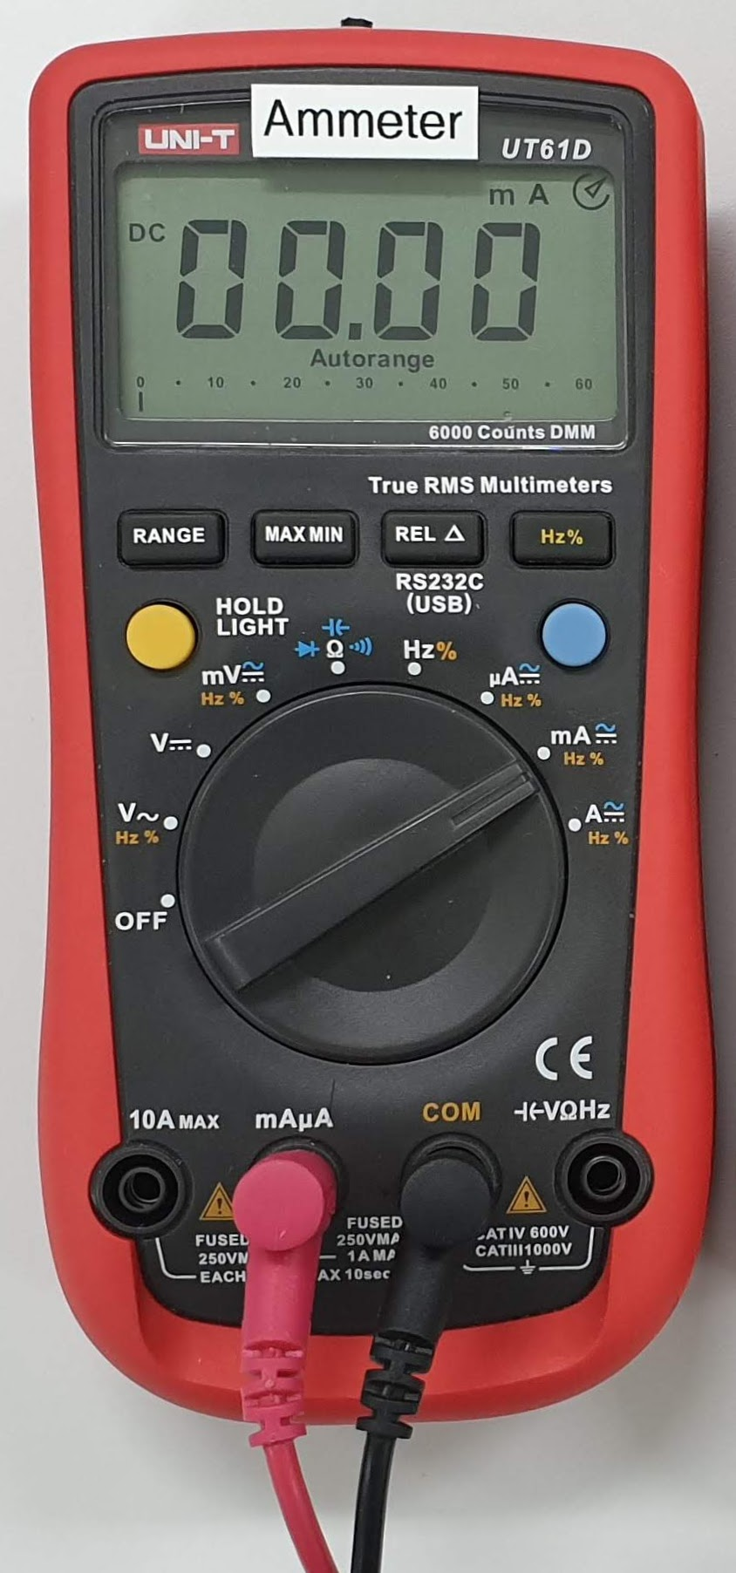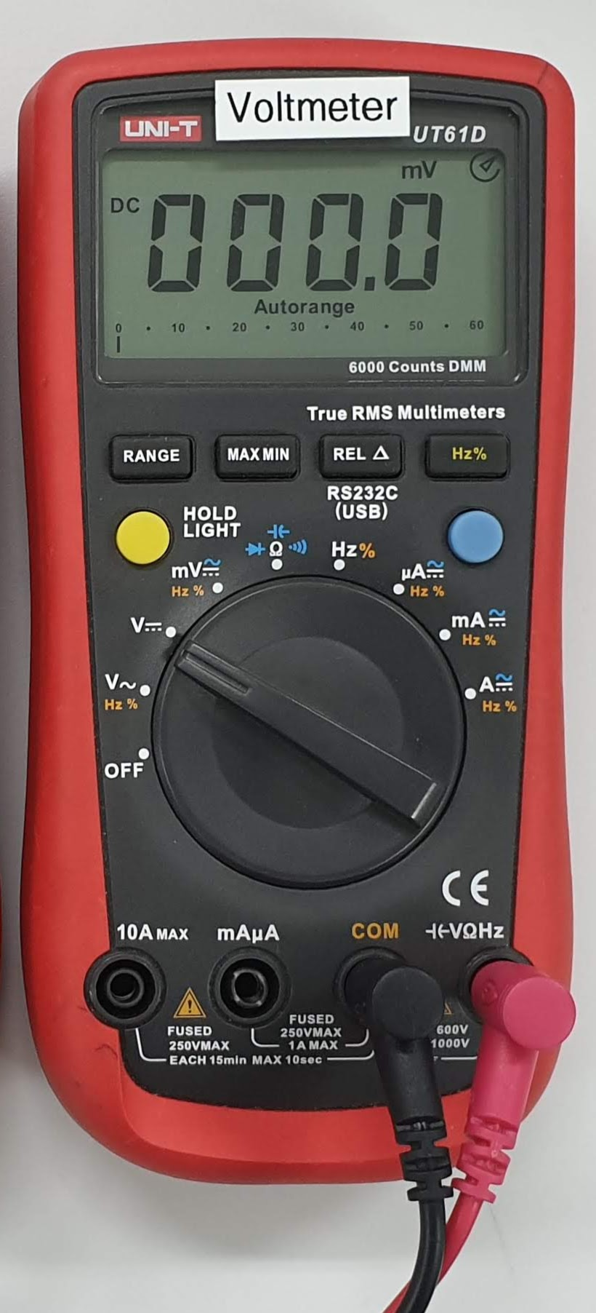

Figure 3.1 Use DMM as an ammeter Figure 3.2 Use DMM as a voltmeter

+

mA

+

−

2.2 k

+

V``

−

−

Figure 3.3 Circuit setup

12 V

10 V

⦁

⦁

⦁

0 V

3.9 Complete the circuit connections in Figure 3.3.

**NOTE:** (1) To measure the current in a resistor, connect a current meter in series with the resistor. (2) To measure the voltage across a resistor, connect a voltmeter in parallel with the resistor.

**NEVER** connect a **current meter** in **PARALLEL** with a device, such as a power supply or a resistor.

3.10 Switch on the power supply, and turn the VOLTAGE knob to increase $V_{R}$ (Voltmeter reading) to 12 V or almost 12 V. Record the voltmeter reading and the ammeter reading to all significant digits.

3.11 Repeat with the other voltages to complete Table 3.1.

|  |  |  |
| --- | --- | --- |
| **Resistor** | $V_{R}$**(V)** | **(mA)** |
| 2.2 k | 12 | *5.49* |
| 2.2 k | 10 | *4.58* |
| 2.2 k | 8 | *3.66* |
| 2.2 k | 6 | *2.74* |
| 2.2 k | 4 | *1.81* |
| 2.2 k | 2 | *0.92* |
| 2.2 k | 0 | *0.00* |

3.12 Plot $V_{R}$ against $I_{R}$. Draw a **straight line** of **best fit** passing through the **origin** (zero).

$V_{R}$ (V)

12

×



×

10

8

×

×

6

×

4

×

2

## Table 3.1

×

$I_{R}$ (mA)

0

1

2

3

4

5

6

3.13 The graph of $V_{R}$ against $I_{R}$ should be a straight line passing the origin (0 V, 0 mA). $V_{R}=mI_{R}$, where $m=$ gradient of the straight line $=$ (resistance by definition).

Find out **from the straight line** on the graph (**NOT** from the data in **Table 3.1**),  
when $V_{R}=11 V$, $I_{R}= ?A$, and when $V_{R}=10 V$, $I_{R}= ?A$.

*When $V_{R}=11 V$, $I_{R}=5.05 mA$*

____________________________________________________________________________

*When $V_{R}=10 V$, $I_{R}=4.59 mA$*

____________________________________________________________________________

Follow the steps below to calculate the gradient or the resistance. The two gradient answers should be the same if the graph could provide infinite resolution.

$$Gradient=Resistance=\frac{ΔV_{R}}{ΔI_{R}}=\frac{V_{R}-0 V}{I_{R}-0 A}=\frac{V_{R}}{I_{R}}=\frac{11 V}{?A}= ?$$

$$Gradient=Resistance=\frac{V_{R}}{I_{R}}=\frac{10 V}{?A}= ?$$

$Resistance=\frac{11 V}{5.05 mA}=$*2.178 kΩ*

$Resistance=\frac{10 V}{4.59 mA}=$____________________________________________________________________________

*2.178 kΩ*

____________________________________________________________________________

Using the gradient of the line of best fit to calculate a resistance can reduce the effect of voltage and current measurement errors.

3.14 **Disconnect the 2.2 k resistor** from the power supply and the ammeter. Use the **DMM with the label of Voltmeter to measure** and record the **actual resistance** of the 2.2 k resistor. Is the measured resistance equal to or very close to the gradient of the straight line?

$Actual or measured resistance=$*2.178 kΩ, which is very close to the gradient of the*

____________________________________________________________________________

*straight line of the V-I characteristics of the resistor.*

____________________________________________________________________________

|  |  |
| --- | --- |
| *Yes, the results of the experiment follow Ohm’s law.* | Do the results of the experiment follow Ohm’s Law, *V* = *IR*?  _____________________________________________________________  _____________________________________________________________ |

**4. CONCLUSION**

*In this experiment, we connected a resistor in series with a power supply, learned more the*

____________________________________________________________________________

*operation of the dc power supply, used a DMM to measure voltage and current, and*

____________________________________________________________________________

*verified that the voltage-to-current ratio of the resistor follows Ohm’s law.*

____________________________________________________________________________